

Sard Verbinnen & Co

**SFDC Strategy/Roadmap**

**Full Report**

**May, 2016**

Contents

Executive Summary 5

Phase 1 (Months 1-3) 5

Phase 2 (Month 4-5) 5

Phase 3 (Month 6-7) 6

Phase 4 (Month (8-12) 6

Phase 5 (1 Year plus) 6

Summary 6

SVC CRM Challenges 7

Relationship Ownership 7

Data Ownership 7

Personally Identifiable Information 8

Contact Visibility 8

Conflict Check Visibility 8

Engagement Visibility 9

Free Text Fields 9

Mobile Devices 9

Reports and Data Export 10

Social Network & Collaboration 10

Relationship Building 10

CRM Strategy 11

Data Migration 13

Microsoft CRM 13

Outlook 13

Spreadsheets / CSV files 14

Financial System / Accounts Receivable 14

Post It Notes, Other 14

3rd Party Tools 15

Data Visibility 15

Object-Level Security 15

Record-Level Security 15

Field-Level Security 16

Roles 16

Sharing Rules 16

Manual Sharing 16

Programmatic Sharing 16

Encryption 17

Design, Development, Testing, Deployment, Training 17

Design 18

Development 18

Testing – Unit Testing 18

Testing – User Acceptance Testing 18

Deployment 18

Training 18

SVC SFDC System 19

Requirements 19

Delivery Approach 19

Schedule 19

Phase 1 (Months 1-3) 19

Phase 2 (Month 4-5) 20

Phase 3 (Month 6-7) 20

Phase 4 (Month (8-12) 21

Phase 5 (1 Year plus) 21

Integrations 21

ADFS 21

Outlook (MS Windows only) 21

OneSource (or Data.com) 21

CRMFusion DemandTools 22

Telephony 22

Cost Estimates 22

Salesforce.com 22

OneSource 22

Data.com 23

CRMFusion DemandTools 23

Development Staff 23

Security 24

Infrastructure 24

Phishing and Malware 24

Security Health Check 24

Auditing 25

Transaction Security Policies 25

Security Certifications 25

Recommendations 25

IP Address Range 25

Limit Users To ADFS Login 25

Two Factor Authentication 25

Primary Point of Contact 25

System Administrator Accounts 25

Require Secure Sessions 26

Session Timeouts 26

Operations 26

Login History 26

Setup Audit Trail 26

Deduplication 26

Account / Contact Last Modified Date/Time 26

Engagement 26

SFDC Backup 26

SFDC Releases 26

SFDC Critical Updates 27

Executive Summary

There is a Chinese proverb which roughly translates as “the longest journey begins with the first step.” Sard Verbinnen & Co (SVC) is taking the first step of a Customer Relationship Management (CRM) transformation by having Capgemini conduct this Salesforce.com Assessment. In order to build a successful CRM strategy and roadmap it is important to understand the current SVC CRM landscape as well as current and future business requirements.

SVC is planning on the use of Salesforce.com to meet SVC’s CRM needs, providing the ability to:

* Quickly and effectively check for client conflicts and engagements,
* Track, grow, and leverage customer relationships,
* Capture and manage material submissions, and
* Establish a solid foundation for growth both in revenue and the IT infrastructure required to drive and support the revenue growth.

Additionally SVC needs to ensure that their CRM tool stays compatible with their back office IT infrastructure and desktop applications and aligns with their security requirements.

During the week of April 11th Capgemini conducted an assessment of SVC’s current client conflict check processes, material submissions, customer relationship management processes, current CRM roadmap, and the impact of the SVC security requirements on the CRM roadmap. During the Discovery Phase Capgemini met with SVC IT leadership, executives, and delivery staff to understand the current client check processes, applications/infrastructure, office and infrastructure locations, data flow, service level requirements and costs.

Capgemini believes that SVC would realize benefits by implementing SFDC using an Agile approach. Agile is recommended because SVC is new to SFDC and Agile is designed to provide a mechanism for managing evolving requirements and solutions.

Capgemini is recommending SVC take a phased approach for deploying SFDC.

Phase 1 (Months 1-3)

Negotiate SFDC Licenses. Configure SFDC Environment. Design, develop and test conflict check and new client functionality. Develop training material. Train support staff. Train end users. Extract-Transform-Load (ETL) conflict check data. Deploy SFDC conflict check in stages.

Phase 2 (Months 4-5)

Design, develop, and test account and contact management functionality. Configure and deploy account and contact loading and cleaning tool. Extract-Transform-Load SVC Client and Relationship Data. Train Support Staff. Train End Users. Deploy SFDC account and contact management in stages.

Phase 3 (Months 6-7)

Design, develop, and test SFDC material submission functionality. Train Support Staff. Train End Users. Deploy SFDC material submission functionality.

Phase 4 (Months (8-12)

Configure and deploy marketing automation. Configure and deploy reporting / business intelligence tool.

Phase 5 (1 Year plus)

Phone integration. Financial system integration.

Summary

Capgemini is confident that SVC can achieve the following benefits by embracing these recommendations:

* Focus on growth instead of infrastructure
* Granular control over the security of SVC data
* Grow from one hundred to one thousand (or more) users without any CRM IT concerns
* Quickly and easily customize the CRM platform to meet evolving business needs

SVC CRM Challenges

All organizations deploying CRM automation face challenges around standardizing their CRM processes and aligning them with the selected automation. Manual CRM processes generally include a certain amount of friction that serve a business purpose. When a contact is in a personal Daytimer™ or in an Outlook contact list the concerns about exposing the data to co-workers is limited. When that data is loaded into CRM automation, though, it is potentially visible to anyone / everyone with access to the SVC SFDC organization. Similarly, when contact information is in a personal Daytimer™ that contact information belongs to the owner of the Daytimer™. Once the contact data is loaded into CRM automation, however, who owns the data? The owner of the Daytimer™ or SVC?

Deploying CRM automation, then, comes with work for IT *and* work for SVC to establish policies and procedures around the CRM automation processes and data.

Relationship Ownership

At SVC business relationships are a critical component of success. When only one person at SVC has a business relationship with a (potential) client or referrer it is will be clear who brought work into SVC. In most cases, though, it is likely that multiple people at SVC know the client and/or referrer. In this scenario there will be less clarity around who owns and manages the ongoing relationship. Relationship “ownership” is important because the “owner” will own maintaining the contact data quality, they will manage internal SVC staff access to the contact data, to some degree they will own keeping the relationship active, and they will potentially benefit / get credit for any work SVC does for the contact.

Today – pre-CRM automation – these issues are generally handled informally e.g. the friction around knowing who-knows-who and who-is-working-on-what is part of the processes that have evolved to manage relationship ownership.

**SVC will need to establish policies and procedures around relationship ownership as well as decide what benefits and responsibilities come with relationship ownership.**

Data Ownership

One of the challenges organizations have in moving to CRM automation is around data ownership. Firms generally establish a blanket policy – *if data is in the CRM automation the firm owns the data*. This has the effect of data not getting entered into the CRM automation because individuals don’t want to give up their ownership of the data and relationship. While a majority of the contacts should have complete information entered in the CRM automation SVC should consider a data ownership policy that requires that at least a contact name and account name get entered into the CRM automation for all relationships and SVC executives have the option to ask that they be contacted for a contact’s phone number, email address, etc.

**SVC will need to establish policies and procedures around data ownership.**

Personally Identifiable Information

Personally Identifiable Information (PII) is information that can be used on its own or with other information to identify, contact, or locate a single person, or to identify an individual in context. Examples of PII include (but are not limited to) full name (if not common), home address, personal phone numbers, personal email address, date of birth, birthplace, spouse’s name, and children’s names. While PII can be useful in maintaining business relationships, storing it in CRM automation can result in significant challenges so PII should not be stored in CRM automation. SVC should not create / make visible PII fields in the CRM automation, SVC will need to create a CRM automation PII policy, this policy should be communicated to users during training, and SVC should regularly scan the system to make sure PII is not being entered in text fields.

**SVC will need to establish policies and procedures around personally identifiable information.**

Contact Visibility

Today at SVC there is no one source for all contact data – employer, full name, phone numbers, email address, street addresses, etc. Instead, varying quality levels of contact information is in multiple locations. This effectively makes it impossible for someone to build a list that is the SVC client and referrer list and share it inappropriately. Or, if the current CRM automation supports mobile devices, to forget a cell phone at the airport that allows someone outside of SVC to use the phone to view the SVC client and referral list. Once the contact data for SVC relationships is all in new CRM automation, however, it will be possible to build a list that is a complete set of information (name, phone, email, street address, etc) for all SVC clients and referrers. CRM automation can be configured to limit access to records and fields but this has to be balanced against giving staff the level of access to data needed for them to do their jobs.

**SVC will need to establish policies, procedures, and security around contact data.**

Conflict Check Visibility

Today at SVC the list of conflict checks is closely held and the details limited to a small number of people. This makes it unlikely someone will build a list of the current and historical SVC conflict checks and share it inappropriately. Or, if the current conflict check system supports mobile devices, to forget a cell phone at the airport that allows someone outside of SVC to use the phone to view the SVC conflict check list. Once the contact data for SVC relationships is all in new CRM automation, however, it will be possible to build a list that is a complete set of information (name, phone, email, street address, etc) for all SVC clients and referrers. CRM automation can be configured to limit access to records and fields but this has to be balanced against giving staff the level of access to data needed for them to do their jobs.

**SVC will need to establish policies, procedures, and security around conflict check data.**

Engagement Visibility

Today at SVC the list of engagements is closely held and the details limited to a small number of people. This makes it unlikely someone will build a list of the current and historical SVC engagements and share it inappropriately. Or, if the current CRM automation supports mobile devices, to forget a cell phone at the airport that allows someone outside of SVC to use the phone to view the SVC engagement list. Once the contact data for SVC relationships is all in new CRM automation, however, it will be possible to build a list that is a complete set of information (name, phone, email, street address, etc) for all SVC clients and referrers. CRM automation can be configured to limit access to records and fields but this has to be balanced against giving staff the level of access to data needed for them to do their jobs.

**SVC will need to establish policies, procedures, and security around engagement data.**

Free Text Fields

Other parts of this document assess contact, conflict check, engagement, and personally identifiable information visibility. All of the data visibility and sharing rules go out the window when an application includes free text fields … which are a part of all modern CRM automation. Account Name, Contact Name, Account Description, Conflict Check Name, etc are all part of the CRM automation functionality that will be used by SVC and which create a risk of users entering data that should be limited to a small circle of people and entering the data in fields that can be viewed by many people. This can be addressed in two ways – by creating data sensitivity polices and reviewing those polices with user during training and by creating a recurring review process where the free test fields are reviewed for inappropriate entries.

**SVC will need to establish policies and procedures around free text fields.**

Mobile Devices

One of the popular features of modern CRM automation is the use of mobile devices e.g. “Information at your fingertips” and “Information when and where you need it.” In addition to apps for most mobile platforms, CRM automation will run with browsers on mobile devices. The friction associated with getting a computer out, booting it up, connecting it to the company VPN, and then connecting to CRM automation tends to mean a user has a good reason for connecting to the CRM automation . Allowing SVC staff to view data in the CRM automation with a couple of taps on a mobile device increases the risk of the data being shared inappropriately. Modern CRM automation can be configured to not allow access from mobile devices, only allow access from mobile devices in the SVC offices or on the SVC VPN, or only allow some users to access some data from mobile devices.

**SVC will need to establish policies and procedures around the use of mobile devices.**

Reports and Data Export

With the contact, conflict check, and engagement data in one place and with users needing access to the data to do their jobs there is a risk that a user will extract data from the system for inappropriate purposes. Modern CRM automation includes report and export functionality combined with the ability to limit what reports a user can run, how much data can be on a report, and if the report can be exported. Additionally CRM automation can give SVC control over whether or not users can design their own reports.

A very restrictive report and export policy will result in significant work for the CRM automation system administrator as each time a user needs a new report they’ll have to go to system administrator.

**SVC will need to establish policies and procedures around reports and data export.**

Social Network & Collaboration

Modern CRM systems usually include some form of social network & collaboration functionality. This functionality is very powerful as it enables:

* Keeping people connected around accounts, contacts, engagements, and topics,
* Keeping an interaction history (instead of burying in people’s email),
* Reducing the number of meetings, and
* Sharing files.

The flipside to social network & collaboration functionality is that it is the “Free Text Field” issue on steroids. Because it encourages people to interact and discuss issues it increases the likelihood that data that should not be shared will be shared.

**SVC will need to establish policies and procedures around social network & collaboration.**

Relationship Building

SVC executives have an enviable set of relationships. SVC would like to encourage junior staff to build relationships with their *peers* at financial and law firms because today’s associate is tomorrow’s managing partner. As SVC associates start to build these relationships it is important that they enter the contact data about the relationships they are building into the CRM automation and that they do not step on the existing SVC executive relationships.

In a perfect world all data in SVC would be complete and correct. The reality is that some of the data will be incomplete and sometimes the data will be incorrect. This means that SVC should err on the side of not stepping on executive relationships by limiting associates to a) building relationships associated with contact data they (the associate) has entered in the CRM automation system and b) only reaching out to contacts in the SVC CRM automation when the contact is at the appropriate level and has been explicitly marked as appropriate for associate relationship building.

**SVC will need to establish policies around CRM automation and associate relationship building.**

CRM Strategy

The CRM / sales / marketing automation landscape is a crowded space that is getting more crowded each day.

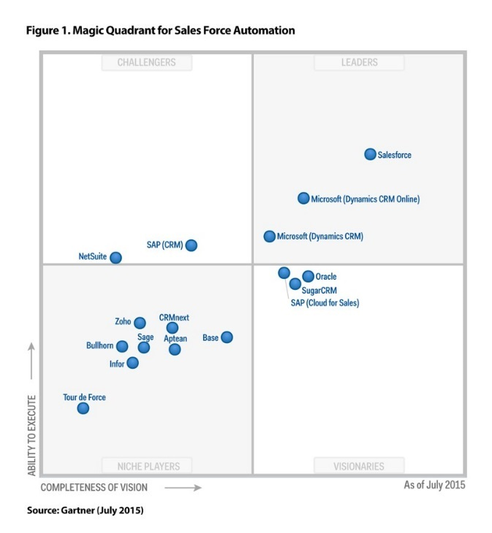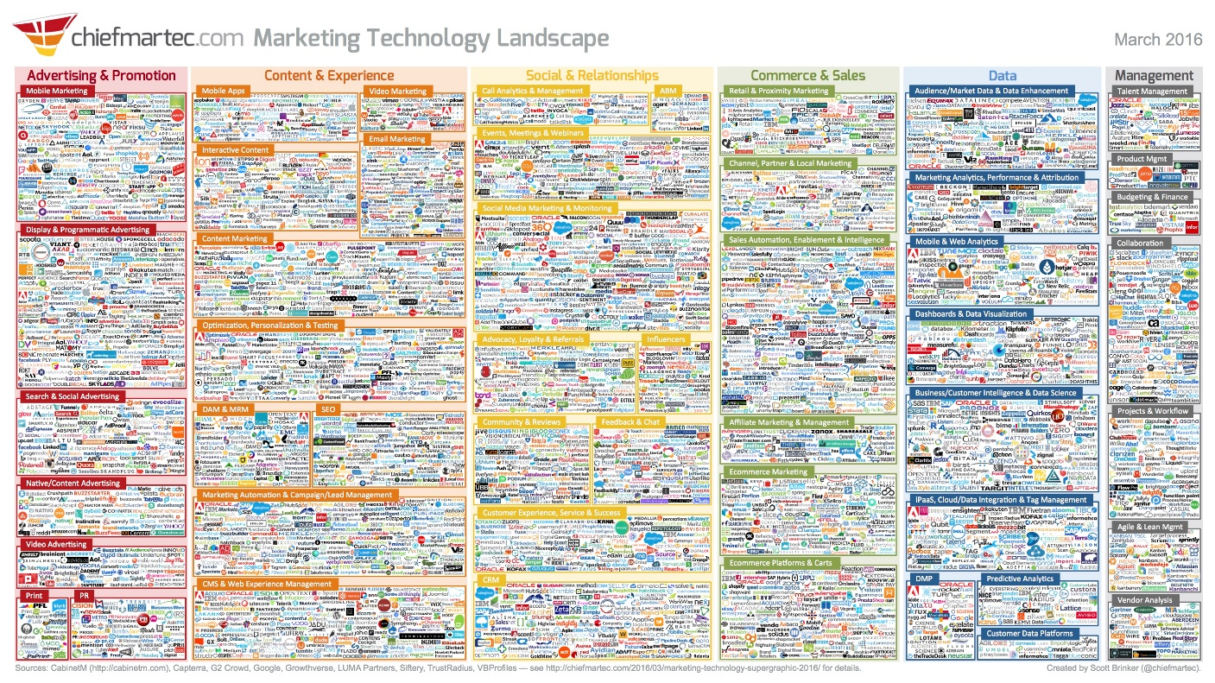

This can present challenges when selecting CRM / sales / marketing automation. The recommended path forward is to start by selecting a product that can serve as a hub for the desired business processes, functionality, features, 3rd party products and in-house customizations.

The Salesforce.com (SFDC) Sales Cloud is the most widely used customer relationship management (CRM) / sales force automation software. In addition to CRM services SFDC offers segment leading services for service automation, marketing automation, customer / partner / employee communities, customer / prospect data quality, and analytics. The SFDC Appexchange offers out of the box (OOTB) extensions as well as integrations with many enterprise systems.

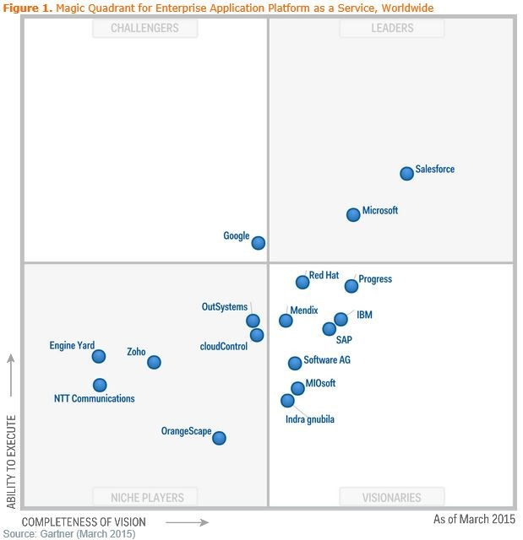SFDC is also the leading platform as a service (PaaS) which enables SVC customizations and integrations to internal systems.

Most SFDC services are hosted in the Cloud.

The “Cloud” is Internet-based computing that provides shared processing resources and data to computers and other devices on demand. It is a model for enabling ubiquitous, on-demand access to a shared pool of configurable computing resources which can be provisioned with minimal management effort. The use of cloud computing and storage solutions provides SVC with the capability to store and process their CRM data in SFDC data centers. It relies on sharing of resources to achieve economy of scale, similar to a utility (like the electricity grid) over a network.

Using cloud computing to address CRM needs allows SVC to avoid upfront infrastructure costs, and focus on projects that differentiate their businesses instead of on infrastructure support. The SFDC Cloud also allows SVC to get their CRM applications up and running faster, with improved manageability and less maintenance, and enables IT to more rapidly adjust resources to meet fluctuating and unpredictable business demand. SFDC uses a "pay as you go" model which only requires SVC to pay for the capacity actually used.

Peter Drucker was one of the first to mention the idea of “core competency” in 1964 when he focused on 'strength analysis'. Simply put, he said that a core competency is something that a firm does really well. It provides the firm’s customers with major benefits. It's not easy for competitors to copy or adopt. It is a set of skills and abilities that can be leveraged to other products and markets. In today’s world non-core-competencies should be outsourced and most IT functions should be (subject to meeting business and security requirements) be outsourced to cloud companies.

SVC CRM technology needs should be outsourced, should be outsourced to a cloud vendor, and since SFDC is the leading CRM cloud vendor and will need SVC’s CRM needs, SVC CRM technology needs should be outsourced to SFDC.

Data Migration

The Extract Transform Load (ETL) processes for moving data from existing systems into SFDC are always more work than initially anticipated. Unstructured or structured, low quality or high quality, up-to-date or out-of-date, and decisions about what constitutes a duplicate – ETL is not just an IT process but needs to include representatives from the business to ensure the data loaded into SFDC is aligned with business needs and expectations.

ETL for the initial data loaded into SFDC is *always* more work than initially budgeted. The data is *always* of poorer quality than assumed. The data *always* triggers conversations, sometimes heated, about who “owns” specific accounts, contacts, and the relationships. ETL is not just an IT process and needs to include business representatives in order to be successful.

Microsoft CRM

The data currently in the SVC Microsoft CRM system will be the least challenging to load into SFDC but that doesn’t mean it will be easy. Microsoft CRM stores data in objects and relationships not dissimilar to the objects and relationships in SFDC. The challenge will be custom fields, formulas, workflows, and code that bases calculations on or manipulates the data in the standard objects as well as any custom objects.

There will likely be data quality issues that should be addressed before the Microsoft CRM data is loaded into SFDC. Because there will likely be data in the Microsoft CRM system that will be duplicated in the other sources, the Microsoft CRM data should be loaded first as the baseline data set.

Before loading data from other sources a tool like CRM Fusion DemandTools should be used to check the data to be loaded against the data in SFDC that was loaded from Microsoft CRM. When duplicates are found (and they *will* be found) the data that “wins” e.g. that ends up in SFDC, should be validated by the business.

The ETL from the SVC Microsoft CRM system to SFDC will require balancing the time and cost of the ETL work against the quantity and quality of the data going into SFDC. Decisions about “good enough” will have to be made and will require input from and signoff by the business.

Outlook

In SVC’s environment today many SVC staff members track their contacts in Outlook. Because SVC uses Exchange it should be possible for an SVC Exchange Administrator to export all contacts in the Exchange database to a CSV file (there may be some intermediate steps, for example, a PST file stage). This data will have many, many duplicates, many personal contacts, and generally be sparse and of only moderate quality. When the Exchange contact data includes account names each contact’s account will have to be matched to an account in SFDC or a new SFDC account record created.

This data will need to be deduplicated before being loaded in SFDC or it can be loaded into SFDC and then immediately deduplicated (using a tool like DemandTools).

When there are duplicates the data will need to be evaluated to determine a) which data “wins” in the deduplication process and b) who ends up owning the data.

Spreadsheets / CSV files

In some cases SVC staff members will track their contacts in Excel / Word / etc documents. Across SVC staff, this data will have many, many duplicates, some personal contacts, and generally be sparse and of only moderate quality. When the contact data includes account names each contact’s account will have to be matched to an account in SFDC or a new SFDC account record created.

This data will need to be deduplicated before being loaded in SFDC or it can be loaded into SFDC and then immediately deduplicated (using a tool like DemandTools).

When there are duplicates the data will need to evaluated to determine a) which data “wins” in the deduplication process and b) who ends up owning the data.

Financial System / Accounts Receivable

The SVC financial system / accounts receivable tracks clients for billing purposes. This data should not have duplicates or personal contacts and should be of good quality. When the financial system / accounts receivable data includes account names each contact’s account will have to be matched to an account in SFDC or a new SFDC account record created.

This data will need to be loaded into SFDC and then, because there will be duplicates with the data already in SFDC, immediately deduplicated (using a tool like DemandTools).

When there are duplicates the data will need to evaluated to determine a) which data “wins” in the deduplication process and b) who ends up owning the data.

Post It Notes, Other

In addition to the data sources previously mentioned, some SVC staff will provide contact data from physical rolodexes, Daytimers™, memory, and yes – Post-It™ Notes. This data will need to be manually entered into a CSV file.

This data will have many, many duplicates, some personal contacts, and generally be sparse and of only moderate quality. When the contact data includes account names each contact’s account will have to be matched to an account in SFDC or a new SFDC account record created.

This data will need to be deduplicated before being loaded in SFDC or it can be loaded into SFDC and then immediately deduplicated (using a tool like DemandTools).

When there are duplicates the data will need to evaluated to determine a) which data “wins” in the deduplication process and b) who ends up owning the data.

3rd Party Tools

According to industry statistics contacts in a CRM system go stale at 25% to 33% a year. While the first line of defense is users that are diligent about keeping “their” data up to data, all but the most diligent users will rapidly find themselves overwhelmed by the effort of keeping contact data accurate and up-to-date.

Capgemini recommends SVC use a tool like [OneSource](https://www.youtube.com/watch?v=x-5qrTs4JcI) or [Data.com](https://www.youtube.com/watch?v=WZpgLMn-tpE) to regularly clean and update that is currently in the SVC SFDC organization as well as augment the existing data with new accounts and contacts that are potentially of interest to SVC.

When OneSource, Data.com, or any of the 3rd party tools “clean” data, the data is sent to the 3rd party vendor. This, then, means that SVC account and contact data is shared with the 3rd party tool vendor.

**SVC should ensure that any agreements with 3rd party vendors include the 3rd party vendor’s responsibility to keep SVC data private.**

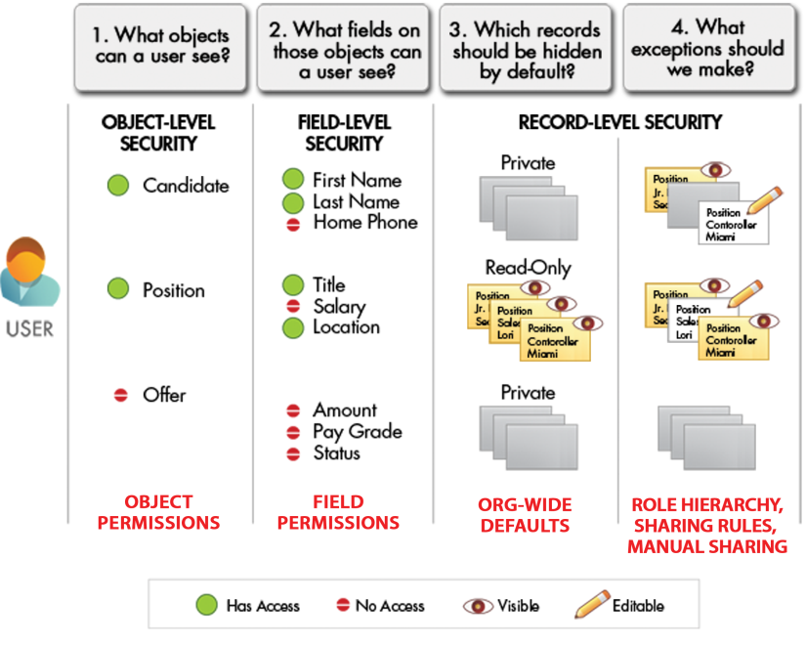Data Visibility

SFDC offers a granular level of control over data visibility at the object level, record level, and field level. Data visibility is managed with organization wide defaults, roles, profiles, permission sets, sharing rules, groups, teams, and programmatic sharing.

The combination of all of these sharing and security settings in SFDC means that SVC can easily specify user permissions for an organization of thousands of users without having to manually configure the permissions for each individual.

Object-Level Security

The bluntest way to control data visibility is by preventing a user from seeing, creating, editing, or deleting any instance of a particular type of object, like a position or review. Object-level access allows SVC to hide whole tabs and objects from particular users, so those users don't even know that type of data exists.

Object-level access is managed with object permissions in user profiles and permission sets.

Record-Level Security

To control data with a little more finesse, SVC can allow particular users to view an object, but then restrict the individual object records that they're allowed to see. For example, record-level access allows a user to see and edit their own contacts, without exposing their contacts to everyone else at SVC.

In SFDC there are several ways of setting record-level access rules:

* Organization-wide defaults (OWD) allow SVC to specify the baseline level of access that a user has in the SVC organization. For example, SVC can configure the OWD so that any user can see any record of a particular object to which their object permissions give them access, but they'll need extra permissions to actually edit a specific record.
* Role hierarchies allow SVC to make sure that a manager will always have access to the same records as his or her subordinates.
* Sharing rules allow SVC to make automatic exceptions to organization-wide defaults for particular groups of users.
* Manual sharing allows record owners to give read and edit permissions to SVC staff who might not have access to the record any other way.

Field-Level Security

With field-level access a user can be prevented from seeing, editing, or deleting the value for a particular field on an object. Field-level access allows SVC to hide sensitive information like the client name or an adverse party or from editing an engagement’s financial details, without having to hide the whole object.

In SFDC, the field-level access is set with field permissions in profiles and permission sets.

Roles

SFDC offers a user role hierarchy that SVC can use with sharing settings to determine the levels of access that users have to SVC SFDC data. Users at any role level can view, edit, and report on all data that’s owned by or shared with users below them in the role hierarchy. Role hierarchies will not align with the SVC corporate structure but instead will represent the data visibility hierarchy.

Sharing Rules

In SFDC record access is first configured at the most restrictive level and then relaxed using sharing rules. Sharing rules are used by administrators to automatically grant users within a given group or role access to records owned by a specific group of users. Sharing rules can be based on record ownership or other criteria.

Manual Sharing

Sharing Rules (above) are configured by SFDC system administrators. SFDC can be configured to allow users to manually share records.

Programmatic Sharing

If sharing rules and manual sharing won’t get the job done, SFDC offers programmatic sharing. While not exactly what SFDC defines as programmatic sharing, during discovery the issue of hiding data entered in the standard Task and Event object came up. This would be done by programmatically shuffling data around so it was only visible to the right users at the right time.

## Encryption

SFDC offers two levels of data encryption: custom field encryption and platform encryption.

Custom field encryption lets SVC encrypt custom fields. Custom field encryption is a standard SFDC feature.

Platform Encryption lets SVC encrypt data stored throughout SFDC. SVC can encrypt sensitive, confidential, and private data to help meet privacy policies, regulatory requirements, and contractual obligations for handling private data. Platform Encryption uses native strong, standards-based encryption. SVC can:

* Encrypt files and attachments.
* Encrypt certain standard and custom fields.
* Use an advanced key management system.

With Platform Encryption, sensitive field data is masked to limit who can see information. Control includes the use of derived data encryption keys and customer-controlled key rotation, generation, and destruction processes. Platform Encryption is an extra cost feature.

Currently, privacy laws in North America do not require the use of Platform Encryption.

**Privacy laws in the EU are in flux and should be monitored by SVC.[1]**

Design, Development, Testing, Deployment, Training

Capgemini is recommending that SVC use an Agile approach for the design, development and deployment of SFDC.

Agile software development is a set of principles for software development in which requirements and solutions evolve through collaboration between self-organizing, cross-functional teams. – Wikipedia

There are many choices for tools to automate Agile processes, but given the scale of the SVC development Capgemini recommends manual processes.

**All prototyping, development, and unit testing should take place in Developer sandboxes. All User Acceptance Testing (UAT) should take place in a Full sandbox. Absolutely no changes should be made directly in the production environment unless they address a critical defect.**

Design

For design and prototyping SVC should use a Developer or Developer Pro sandbox. Because SFDC is new to SVC and Lightning (the SFDC UI) is new to SFDC, the best way to explore new features and determine system design will be to take the SFDC Trailhead classes and apply the learning in a sandbox.

Development

For development SVC should use a Developer or Developer Pro sandbox *different from the design sandbox*.

The development sandbox should be refreshed before each sprint begins.

Changes should be moved from sandbox to sandbox using change sets or Eclipse (Force.com IDE).

Changes can be moved via ANT but ANT has more overhead than is appropriate for SVC. GitHub, SVN or one of the other code repositories have more overhead than is appropriate for SVC. Continuous integration using Jenkins, code evaluation using SonarQube, etc – all have more overhead than is appropriate for SVC.

Testing – Unit Testing

Unit testing should be performed in the same Developer sandbox used for development. The unit testing should be comprehensive and script based, and the results should be logged. Once the updates have passed unit testing the updates should be pushed to the Full sandbox via change sets or Eclipse.

Testing – User Acceptance Testing

User Acceptance Testing (UAT) should be performed in the Full sandbox. The UAT should be comprehensive and script based, and the results should be logged. To the degree possible UAT should be performed by business users.

Once the updates have passed UAT the updates should be pushed to the production SFDC organization via change sets or Eclipse.

The Full sandbox should be refreshed before each sprint begins.

**When the Full sandbox is refreshed some of the data may need to be obfuscated.**

Deployment

Updates that have passed UAT should be pushed to the production SFDC organization on a schedule that minimizes the impact of the changes on production users. This is generally on a Friday after 6PM ET or on a Saturday morning. Updates pushed to production should be smoke tested.

Training

Capgemini recommends that SVC training consist of in-person group training with PowerPoint based handouts, a Word based User Guide, and short (three to five minute) Camtesia or Captivate based training videos. The basic training should be offered once a month. For the first six months once a week SVC should operate an open conference call where users can dial in to ask questions.

SVC SFDC System

Requirements

* Contact management – Enter and maintain account and contact information
* Activity logging – Log calls, meetings, and relationship management activities
* Conflict check
* New engagement
* Material submission
* ADFS integration
* Other integrations

Delivery Approach

Capgemini recommends SVC take an Agile approach to delivering the SFDC based service. The core tenets of Agile are a) at the end of a sprint working production ready features are delivered, b) requirements are expected to change, so c) at the beginning of each sprint the revised requirements can be revisited. Because SFDC is new to SVC the delivery is likely to follow the standard new tool process e.g. users won’t know what they want until they see what’s been done. Then what the users want will evolve steadily for a period of time. An important component of a successful deployment is face time. Nothing beats the training and initial support being provided in-person and hands-on.

Schedule

Phase 1 (Months 1-3)

* **Negotiate SFDC Licenses** – This will not delay development as SFDC is generally good about extending trials as needed.
* **Configure SFDC Environment** – Basic SFDC configuration is generally about a week of work. Once the basic configuration work is done the first Developer and Full sandboxes can be created.
* **Design, develop and test conflict check and new client functionality** – While the design will probably evolve over the first one to two sprints, the current thought is to base the conflict check and new client forms on the SFDC Opportunity object, record types and page layouts. This is an out of the box (OOTB) approach. This approach has been instantiated in the prototype turned over to SVC.
* **Develop training material** – Develop a PowerPoint based deck for instructor led training, a Word based User guide, and several short (three to five minute) videos for specific activities. The training material should include using SFDC from mobile devices.
* **Train support staff** – The support staff should be provided the training deck, the User Guide, the videos, user accounts in the Full sandbox, and an extended version of the end user training as they will be performing the Level 1 and Level 2 support.
* **Train end users** - The users should be provided the training deck, the User Guide, the videos, user accounts in the Full sandbox, and the end user training. The training will be thirty to forty five minutes long and should be offered in-person and via screen sharing once a day for the first two weeks and once a month thereafter.
* **Extract-Transform-Load (ETL) conflict check and new client data** – This should be a fairly straightforward exercise of loading the existing conflict check spreadsheet into SFDC.
* **Deploy SFDC conflict check and new client functionality in stages** – Because the conflict check and new client functionality will still have a manual component that is similar to what is done today it should be possible to pilot the SFDC based conflict check and then deploy it is stages.

Phase 2 (Month 4-5)

* **Design, develop, and test account and contact management functionality** – This is close to OOTB SFDC functionality. The only complexity will be the SFDC add-in for Outlook (if SVC elects to deploy it).
* **Configure and deploy account and contact loading and cleaning tool** – This is OneSource or Data.com and is about an hour of configuration work e.g. fairly easy. The system admin need to spend one to two days learning how to use the tool.
* **Extract-Transform-Load SVC Client and Relationship Data** – This is going to be a tremendous amount of work. Capgemini would recommend budgeting six man weeks for this task *excluding* the time business users spend.
* **Develop Training Material** - Develop a PowerPoint based deck for instructor led training, augment the Word based User guide, and several short (three to five minute) videos for specific activities. The training material should include using SFDC from mobile devices.
* **Train Support Staff** - The support staff should be provided the training deck, the User Guide, the videos, user accounts in the Full sandbox, and an extended version of the end user training as they will be performing the Level 1 and Level 2 support.
* **Training End Users** - The users should be provided the training deck, the User Guide, the videos, user accounts in the Full sandbox, and the end user training. The training will be forty five minutes to one hour long and should be offered in-person and via screen sharing once a day for the first two weeks and once a month thereafter.
* **Deploy SFDC account and contact management in stages** – This is the first change that will materially impact SVC users and ask that they change their behavior. It should be rolled out to a handful of people at a time with significant support so any issues are quickly addressed.

Phase 3 (Month 6-7)

* **Design, develop, and test SFDC material submission** **functionality** - While the design will probably evolve over the first one to two sprints, the current thought is to base the material submission functionality on a custom object.
* **Develop Training Material** - Develop a PowerPoint based deck for instructor led training, augment the Word based User guide, and several short (three to five minute) videos for specific activities. The training material should include using SFDC from mobile devices.
* **Train Support Staff** - The support staff should be provided the training deck, the User Guide, the videos, user accounts in the Full sandbox, and an extended version of the end user training as they will be performing the Level 1 and Level 2 support.
* **Training End Users** - The users should be provided the training deck, the User Guide, the videos, user accounts in the Full sandbox, and the end user training. The training will be thirty to forty five minutes long and should be offered in-person and via screen sharing once a day for the first two weeks and once a month thereafter.
* **Deploy SFDC material submission functionality** - This should be rolled out to a handful of people at a time with significant support so any issues are quickly addressed.

Phase 4 (Month (8-12)

* **Configure and deploy marketing automation** – This should be straight forward to configure and deploy. There will be a learning curve for the marketing team members that will use the automation but it will be a small group of motivated people.
* **Configure and deploy reporting / business intelligence tool** - This should be straight forward to configure and deploy. There will be a learning curve for the users that will use the automation but it will be a small group of motivated people.

Phase 5 (1 Year plus)

* **Telephony integration**
* **Financial system integration**

Integrations

ADFS

SFDC will be integrated with ADFS by SVC IT staff.

Outlook (MS Windows only)

SFDC offers out of the box (OOTB) integration with MS Outlook on MS Windows. This facilitates logging email and meetings in SFDC. The SFDC configuration is about 15 minutes of work. The deployment and installation of the SFDC add-in for Outlook would be handled by SVC IT staff.

OneSource (or Data.com)

OneSource configuration is about an hour of work. As noted elsewhere in this document, however, using OneSource does share SVC data with OneSource which means there are security and legal issues to be addressed.

CRMFusion DemandTools

DemandTools is a Windows application that takes about 15 minutes to install. DemandTools connects to SFDC and to the CRMFusion website (to validate the licenses). Because it connects to the CRMFusion website there are security and legal issues to be addressed.

Telephony

Tenfold is Computer Telephony Integration (CTI) software that sits between SFDC and the SVC PBXs and displays account and contact information on a user’s computer screen during the user’s in-bound and out-bound calls.

Charlie

Charlie combs through 100s of sources and automatically sends SVC users a one‐pager on everyone they’re going to meet with, before they see them. Charlie has computer, mobile, and SFDC interfaces.

Cost Estimates

Using SFDC is an evolutionary process. Over time as SVC uses SFDC there will be interest in an assortment of consulting, add-ins and integrations. Cost estimates for the first two phases are listed below.

Salesforce.com

SFDC will provide a complete view of SVC clients and referrers, including activity history, key contacts, customer communications, internal discussions, and (depending on security and permission configurations) conflicts checks and engagements.

* SFDC Sales Cloud Enterprise is $125/seat/month.
* SFDC Premium and Premium+ support retail at roughly 40% of the seat price.

<https://www.salesforce.com/assets/pdf/success-services/premier-success-plans.pdf>

SFDC will negotiate prices esp. where volume is concerned.

OneSource

OneSource gives SVC direct access to high quality company information and contact profiles that can be downloaded to SFDC. A typical company profile in OneSource includes more than a dozen different reports ranging from company summaries to contacts, competitors, and significant developments.

* Avention Essential Global
  + $12,000/yr up to 5 seats
    - Comes with 2,500 email downloads
  + $19,000/yr up to 10 seats
    - Comes with 2,500 email downloads
  + $31,000/yr up to 25 seats
    - Can provide 5,000 email downloads
  + $80,000/yr up to 100 seats
    - Can provide 20,000 email downloads
  + Above options include:
    - Unlimited searches and views
    - 500,000 exports/downloads of companies and contacts without email (for all users combined)
  + Each additional 2,500 email downloads on top of what’s included in the annual subscription is $n,nnn

Data.com

Data.com Clean is a data cleansing solution natively integrated into Salesforce and helps businesses better control and maintain high-quality customer data. Data.com Prospector gives SVC direct access to a wealth of the highest quality company and contact profiles, along with relevant account research and insights to get the most from every conversation.

* Clean Premium $25/seat/month
* Prospector Premium $150/seat/month

SFDC will negotiate prices esp. where volume is concerned. Please note: SFDC requires a data.com seat for all users in an SFDC organization.

CRMFusion DemandTools

DemandTools is the leading data quality & data cleansing toolset for SFDC worldwide. DemandTools is a suite of 10+ individual data quality modules to control, standardize, deduplicate, import and generally manipulate Salesforce and/or Force.com data. DemandTools is a client-based application that Salesforce administrator’s install on their Microsoft Windows computer.

DemandTools pricing is based on the number of System Administrators in the SFDC organization. SVC is estimated to have three System Administrators. CRMFusion charges a one time set up fee.

* One $ 5,000
* Two $ 7,500
* Three $ 10,000
* Four $ 12,500
* Five and above Please Call

Development Staff

SFDC Senior Developers in New York City range from $100/hr to $200/hr. The schedule should only require one developer and is designed so each piece of work can have a gap between it and be performed by a different developer.

Tenfold

Tenfold is Computer Telephony Integration (CTI) software that sits between SFDC and the SVC PBXs. Retail pricing for Tenfold is $79/seat/month and SVC will need 100 seats at the current staff levels.

Charlie

Charlie combs through 100s of sources and automatically sends SVC users a one‐pager on everyone they’re going to meet with, before they see them. Retail pricing for Charlie is $75/seat/year and SVC will need 100 seats at the current staff levels.

Security

SFDC understands that the confidentiality, integrity, and availability of SVC’s information are vital to SVC’s business operations. SFDC uses a multi-layered approach to protect that key information, constantly monitoring and improving their application, systems, and processes to meet the demands and challenges of security. At the configuration and development level SFDC provides sophisticated controls that gives SVC granular control over the visibility of their data.

The Salesforce Security Guide can be downloaded from:

<http://resources.docs.salesforce.com/200/18/en-us/sfdc/pdf/salesforce_security_impl_guide.pdf>

The Salesforce CRM Security Audit Guide can be downloaded from:

<https://s3.amazonaws.com/dfc-wiki/en/images/f/fb/Salesforce_CRM_Security_Audit_Guide.PDF>

Some of the topics of interest to SVC are highlighted below.

Infrastructure

*Phishing and Malware*

*Trust starts with transparency. That’s why Salesforce displays real-time information on system performance and security on the trust site at* [*http://trust.salesforce.com*](http://trust.salesforce.com)*. This site provides live data on system performance, alerts for current and recent phishing and malware attempts, and tips on best security practices for your organization.*

*Security Health Check*

*Health Check lets you identify and fix security vulnerabilities in your password policies, network access configuration, and session settings, all from a single page. A summary score shows how your org measures against the Salesforce-recommended baseline.*

*Auditing*

*Auditing features don't secure your organization by themselves; they provide information about usage of the system, which can be critical in diagnosing potential or real security issues. Someone in your organization should do regular audits to detect potential abuse.*

*Transaction Security Policies*

*Policies evaluate activity using events you specify. For each policy, you define real-time actions, such as notify, block, force two-factor authentication, or choose a session to end.*

*Security Certifications*

*Salesforce.com’s services are certified as compliant with some of the most rigorous, industry-accepted security, privacy, and reliability standards. We are certified and audited to standards as a service provider with the ISO/IEC 27001:2005 standard (including ISO 27001), SAS 70 Type II (now SSAE No. 16), SysTrust, and the EU-US and Swiss-US Safe Harbor frameworks).*

SFDC will provide copies of the audits on request (after receipt of an NDA signed by SVC).

Recommendations

IP Address Range

Salesforce.com can be configured to limit access to the SVC SFDC organization to specific IP address ranges. This is can be used to require that SVC users are in an SVC office or on the SVC VPN before they can connect to SFDC.

Limit Users To ADFS Login

Salesforce.com can be configured to limit users to only logging in via their AD username / password. This increases the security of the system but then requires that ADFS is working and SFDC can connect to ADFS. If ADFS is not working SFDC support can disable the requirement for ADFS.

Two Factor Authentication

Salesforce.com can be configured to always require two factor authentication or require two factor authentication when working outside of an SVC office / outside of the SVC VPN.

Primary Point of Contact

Salesforce.com can be configured to limit the number of people at SVC that can contact SFDC Support. This should be done and should be a small number of people. The people on this list should be tracked by SVC and when people’s roles change the list of should be updated.

System Administrator Accounts

Any user that has a system administrator account and is a regular user of the system should have two user accounts. The system administrator account should only be used for system administrator functions and the regular user account should be used for all other activities.

Require Secure Sessions

All sessions should be secure e.g. require the use of HTTPS.

Session Timeouts

The SFDC default session timeout is two (20) hours. This should be reduced to between thirty (30) minutes and one (1) hour.

Operations

The SFDC Level 1 and Level 2 support functions should be covered by the existing help desk. Level 3 support should be provided by the SFDC administration staff. If possible the SFDC administration staff should have user accounts in the existing help desk ticketing system.

In addition to the support activities the SFDC administrator(s) should perform the activities below.

Login History

Once a week the system admin should review the Login History.

Setup Audit Trail

Once a week the system admin should review the Setup Audit Trail.

Deduplication

Once a week the system admin should deduplicate the account, contact, and (if in use) lead data.

## Account / Contact Last Modified Date/Time

Once a week the system admin should check the last modified date/time of accounts and contacts, sorted by owner, to get a sense of which data may be getting stale.

## Engagement

Once a week the system admin should check engagements by age and last modified to see if the engagement can be closed.

SFDC Backup

Once a week the system admin should copy the SFDC backup files to an SVC file server.

SFDC Releases

Three times a year SFDC does a major release. Deployment of these releases is not optional e.g. SFDC will tell SVC when the release will be pushed to the SVC SFDC organization. SFDC will publish release notes several months before the release goes live. The system admin should read the release notes and make sure there is nothing that will damage the SVC SFDC organization.

SFDC Critical Updates

SFDC releases critical updates fairly regularly. SVC will generally get several months of warning before the critical releases are deployed. It is strongly recommended that the critical release be tested in a Sandbox.

1. As per the SOW Capgemini is *not* providing legal advice. It is up to SVC to determine the laws and regulations that apply to SVC data.